Project Flow
In a healthcare facility, a medical staff member uses the Predictive Pulse system to analyse a patient’s health condition. The process begins when the healthcare provider enters the patient’s demographic details and blood test parameters through the system interface. These details may include age, gender, haemoglobin levels, and other clinical indicators.
Once the information is entered, the system performs data validation and preprocessing. During this stage, the input data is cleaned and standardized using a trained scaler, ensuring that the values match the format used when training the machine learning model.
After preprocessing, the standardized data is passed to the integrated machine learning model. The model analyses the patterns in the patient’s health parameters and determines whether the patient is likely to have anaemia or not.
The system then generates a prediction result, displaying either “Anaemia” or “No Anaemia”, along with a confidence score that indicates the probability of the prediction. This helps healthcare professionals understand how reliable the prediction is.
Finally, the system provides clinical interpretation and health recommendations. These recommendations assist doctors in deciding whether the patient requires further medical tests, dietary changes, or immediate treatment.
Through this automated workflow, the Predictive Pulse system helps healthcare professionals make faster and more informed clinical decisions.
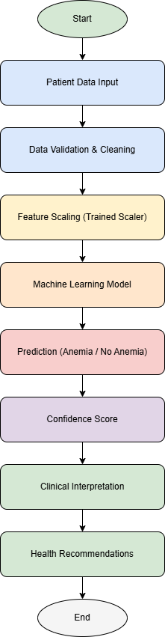

Project Activities
